**PIZZA SALES SQL QUERIES**

**A. KPI’S**

**1. Total Revenue:**

select SUM(total_price) as Total_Revenue from pizza_sales

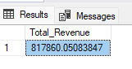

**2. Average Order Value**

select SUM(total_price) / COUNT(distinct order_id) as Avg_Order_Value from pizza_sales

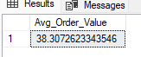

**3. Total Pizza Sold**

select SUM(quantity) as Total_Pizza_Sold from pizza_sales

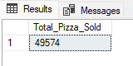

**4. Total Orders**

select COUNT(distinct order_id) as Total_orders from pizza_sales

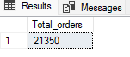

**5. Average Pizzas Per Order**

select cast(CAST(sum(quantity) as decimal(10,2)) /

cast(COUNT(distinct order_id) as decimal(10,2)) as decimal(10,2)) as Avg_Pizzas_Per_Order from pizza_sales

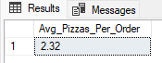

**B. Daily Trend for Total Orders**

select DATENAME(DW, order_date)as order_day , count(distinct order_id) as Total_Orders

from pizza_sales

group by DATENAME(DW, order_date)

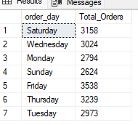

**C. Hourly Trend for Orders**

select DATEPART(hour, order_time)as order_hour , count(distinct order_id) as Total_Orders

from pizza_sales

group by DATEPART(hour, order_time)

order by DATEPART(hour, order_time)

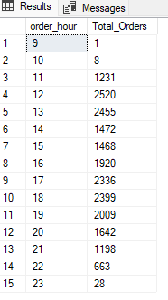

**D. Weekly Trend for Total Orders**

select DATEPART(iso_week, order_date) as Week_Number, YEAR(order_date) as Order_Year,

count (distinct order_id) as Total_Orders from pizza_sales

group by DATEPART(iso_week, order_date),YEAR(order_date)

order by DATEPART(iso_week, order_date),YEAR(order_date)

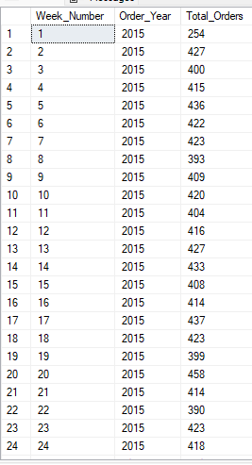

**E. Percentage% of sales by Pizza Category:**

select pizza_category, cast(sum(total_price) AS decimal(10,2)) as Total_Revenue, CAST(sum(total_price) * 100/

(SELECT sum(total_price) from pizza_sales) AS decimal(10,2)) AS PCT

from pizza_sales

GROUP BY pizza_category

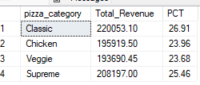

**F. Percentage % of Sales by Pizza Size:**

select pizza_size, cast(sum(total_price) AS decimal(10,2)) as Total_Sales, CAST(sum(total_price) * 100/

(SELECT sum(total_price) from pizza_sales) AS decimal(10,2)) AS PCT

from pizza_sales

GROUP BY pizza_size

ORDER BY PCT DESC

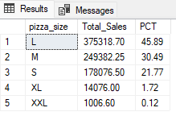

**G. Total Pizzas Sold by Pizza Category:**

select pizza_category, sum(quantity) as Total_Quantity_Sold from pizza_sales

where MONTH(order_date) = 2

group by pizza_category

order by Total_Quantity_Sold DESC

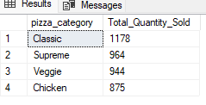

**10. Top 5 Pizza by Revenue :**

select Top 5 pizza_name, sum(total_price) as Total_Revenue from pizza_sales

group by pizza_name

order by Total_Revenue DESC

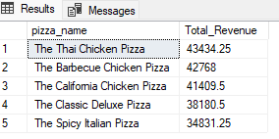

**11. Bottom 5 Pizza by Revenue:**

select Top 5 pizza_name, sum(total_price) as Total_Revenue from pizza_sales

group by pizza_name

order by Total_Revenue ASC

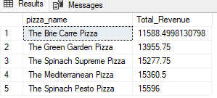

**12. Top 5 Pizza by Quantity:**

select Top 5 pizza_name, sum(quantity) as Total_Quantity from pizza_sales

group by pizza_name

order by Total_Quantity DESC

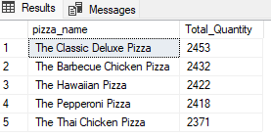

**13. Bottom 5 Pizza by Quantity:**

select Top 5 pizza_name, sum(quantity) as Total_Quantity from pizza_sales

group by pizza_name

order by Total_Quantity ASC

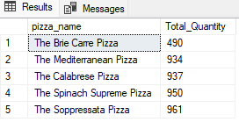

**14. Top 5 Pizza by Total Orders:**

select Top 5 pizza_name, count(distinct order_id) as Total_Order from pizza_sales

group by pizza_name

order by Total_Order DESC

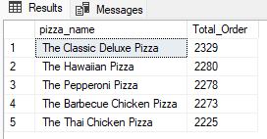

**15. Bottom 5 Pizza by Total Orders:**

select Top 5 pizza_name, count(distinct order_id) as Total_Order from pizza_sales

group by pizza_name

order by Total_Order ASC

